**Security Service Management System**

**Assignment 2 - Project Progress Review**



**Sri Lanka Institute of Information Technology**

**IT2080 – Information Technology Project**

**Group ID: ITP24R_B1_W22**

**September 2024**

**Declaration**

This project report is our original work, and the content is not plagiarized from any resource, References for all the content taken from external resources are correctly cited. To the best of our knowledge, this report does not contain any material published or written by third parties, expect as acknowledged in the text.

**Authors:**

|  |  |  |
| --- | --- | --- |
| **Author SID** | **Author Name with Initials** | **Signature** |
| IT22325228 | Fernando K. K. C |  |
| IT22907998 | Sadisha R. M. M |  |
| IT20145552 | Dissanayaka D. M. S. M |  |
| IT22257086 | Randiw E. Y |  |
| IT22293480 | Jayodhya J. D. H |  |
| IT22127082 | Medawatte W. W. M. T. N. B |  |
| IT22132628 | Kusumsiri P. A. S. S |  |
| IT22197146 | Ranasinghe R. A. R. V. C |  |

**Date:** 22.09.2024

**Contents**

Section 01 - Progress 4

Section 02 5

2.1. ER Diagram 5

2.2. Normalized Schema 5

2.3. Test Case Design 6

2.4. High-level System Design 7

Section 03 8

3.1. Module of the Group Members working 8

3.2. Completion Level of the Features 9

IT22325228 – Fernando K. K. C 9

User Management 9

IT22907998 – Sadisha R. M. M 10

Training Management 10

IT20145552 – Dissanayaka D. M. S. M 10

Client Management 10

IT22257086 – Randiw E. Y 11

Booking Management 11

IT22293480 – Jayodhya J. D. H 11

Payment Management 11

IT22127082 – Medawatte W. W. M. T. N. B 12

Operation Management 12

IT22132628 – Kusumsiri P. A. S. S 12

Inventory Management 12

IT22132628 – Kusumsiri P. A. S. S 13

Leave Management 13

3.3. MongoDB Database 13

3.4. Algorithms 14

Section 04 - Individual Contribution 15

Section 05 - Appendix 16

# Section 01 - Progress

*Table 1.1: Progress*

|  |  |  |  |  |
| --- | --- | --- | --- | --- |
| **High level user story / Function** | | **Completion Level** | | **Responsible Member** |
| **Completed** | **Completed by Final** |
| User Management | User Registration | Checkbox Checked with solid fill |  | IT22325228  Fernando K. K. C |
| User Login | Checkbox Checked with solid fill |  |
| Admin Login | Checkbox Checked with solid fill |  |
| User Profile | Checkbox Checked with solid fill |  |
| Filter | Checkbox Checked with solid fill |  |
| Search | Checkbox Checked with solid fill |  |
| Password Reset with OTP |  | Checkbox Checked with solid fill |
| Generate Report |  | Checkbox Checked with solid fill |
| Training Management | Manage Training Course | Checkbox Checked with solid fill |  | IT22907998  Sadisha R. M. M |
| Search | Checkbox Checked with solid fill |  |
| Generate Report |  | Checkbox Checked with solid fill |
| Client Management | Manage Client Inquiry | Checkbox Checked with solid fill |  | IT20145552  Dissanayaka D. M. S. M |
| Search | Checkbox Checked with solid fill |  |
| Generate Report |  | Checkbox Checked with solid fill |
| Booking Management | Manage Bookings | Checkbox Checked with solid fill |  | IT22257086  Randiw E. Y |
| Search | Checkbox Checked with solid fill |  |
| Generate Report |  | Checkbox Checked with solid fill |
| Payment Management | Manage Payments | Checkbox Checked with solid fill |  | IT22293480  Jayodhya J. D. H |
| Search | Checkbox Checked with solid fill |  |
| Generate Report |  | Checkbox Checked with solid fill |
| Operation Management | Manage Operations | Checkbox Checked with solid fill |  | IT22127082  Medawatte W. W. M. T. N. B |
| Search | Checkbox Checked with solid fill |  |
| Generate Report |  | Checkbox Checked with solid fill |
| Inventory Management | Manage Inventory | Checkbox Checked with solid fill |  | IT22132628  Kusumsiri P. A. S. S |
| Search | Checkbox Checked with solid fill |  |
| Generate Report |  | Checkbox Checked with solid fill |
| Leave Management | Manage Leaves | Checkbox Checked with solid fill |  | IT22197146  Ranasinghe R. A. R. V. C |
| Search | Checkbox Checked with solid fill |  |
| Generate Report |  | Checkbox Checked with solid fill |

Repository: <https://github.com/CharuniFernando/Security-Service-Management-System.git>

# Section 02

## 2.1. ER Diagram

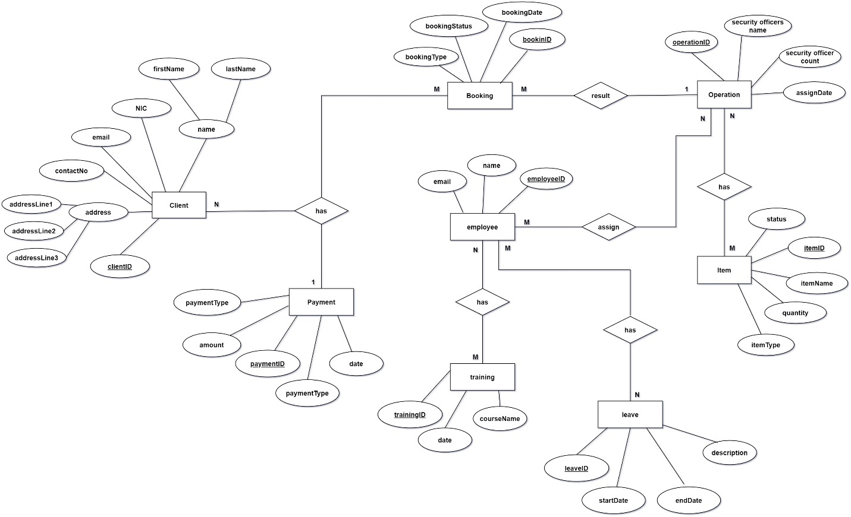

*Figure 2.1.1: ER Diagram*

## 2.2. Normalized Schema

**Client** (clientID, first name, last name, nic, email, contactNo, address)

**Payment** (paymentID, paymentType, amount, date, *clientID*)

**Booking** (bookingID, bookingDate, bookingStatus, bookingType, *clientID*)

**Employee** (employeeID, name, email)

**Operation** (operationID, securityOfficerCount, assignDate, *bookingID*)

**Item** (itemID, itemName, quantity, itemType, status, *operationID*)

**Training** (trainingID, courseName, date, *employeeID*)

**Leave** (leaveID, description, startDate, endDate, *employeeID*)

## 2.3. Test Case Design

*Table 2.3.1: Test Case Design*

|  |  |  |  |
| --- | --- | --- | --- |
| **Function** | **Test Case ID** | **Description** | **Precondition** |
| User Management | UM01 | Verify user registration | User must be on the registration page. |
| UM02 | Verify login functionality | Registered user exists in the database. |
| Training Management | TM01 | Verify course creation by the manager | Manager must be logged in. |
| TM02 | Verify course assignment to security officers | Courses and security officers must exist in the system. |
| Client Management | CM01 | Verify client feedback submission | Client must be logged in. |
| CM02 | Verify that an admin can view client inquiry | Client inquiries must exist in the system. |
| Booking Management | BM01 | Verify booking of security officers by the client | Client must be logged in. |
| BM02 | Verify cancellation of booking | A booking must exist. |
| Payment Management | PM01 | Verify invoice generation after booking completion | A completed booking exists. |
| PM02 | Verify payment processing for a booking | An invoice must be generated. |
| Operation Management | OM01 | Verify assignment of security officers to a location | Security officers and a client location must exist. |
| OM02 | Verify notifications for assigned security officers | Security officers must be assigned to a location. |
| Inventory Management | IM01 | Verify adding inventory items by admin | Admin must be logged in. |
| IM02 | Verify inventory item assignment to security officers. | Inventory items and security officers must exist. |
| Leave Management | LM01 | Verify security officer leave application submission | Security officer must be logged in. |
| LM02 | Verify leave approval by the manager | A leave request must exist |

## 2.4. High-level System Design

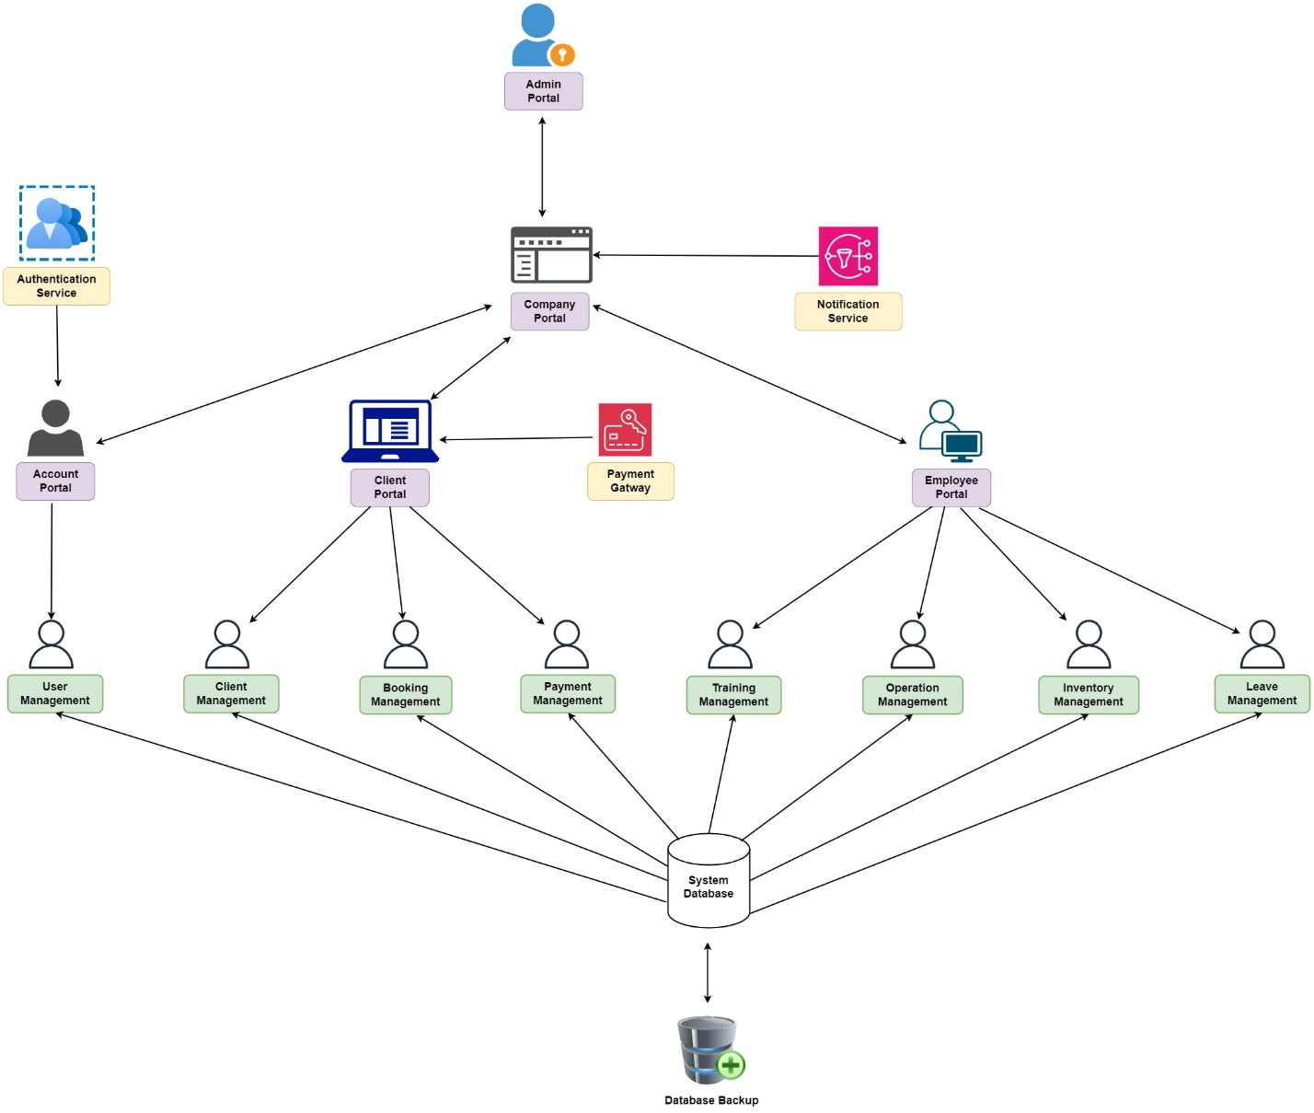

*Figure 2.4.1: High-level System Design*

# Section 03

## 3.1. Module of the Group Members working

*Table 3.1.1: Module of the Group Members working*

|  |  |  |
| --- | --- | --- |
| **Responsible Member** | **Module** | **Description** |
|
| IT22325228  Fernando K. K. C | Home Page and Navigation | Home and Navigation is Completed in the web Application |
| User Management | User Registration |
| User Login |
| Admin Login |
| User Profile |
| Filter |
| Search |
| Password Reset with OTP |
| Generate Report |
| IT22907998  Sadisha R. M. M | Training Management | Manage Training Course |
| Search |
| Generate Report |
| IT20145552  Dissanayaka D. M. S. M | Client Management | Manage Client Inquiry |
| Search |
| Generate Report |
| IT22257086  Randiw E. Y | Booking Management | Manage Bookings |
| Search |
| Generate Report |
| IT22293480  Jayodhya J. D. H | Payment Management | Manage Payments |
| Search |
| Generate Report |
| IT22127082  Medawatte W. W. M. T. N. B | Operation Management | Manage Operations |
| Search |
| Generate Report |
| IT22132628  Kusumsiri P. A. S. S | Inventory Management | Manage Inventory |
| Search |
| Generate Report |
| IT22197146  Ranasinghe R. A. R. V. C | Leave Management | Manage Leaves |
| Search |
| Generate Report |

## 3.2. Completion Level of the Features

### IT22325228 – Fernando K. K. C

### User Management

**Completion Level**: 90%

*Table 3.2.1: User Management*

|  |  |  |
| --- | --- | --- |
| **Features** | **Completion Level** | **Description** |
| User login and Registration | Completed | Users (clients and employees) can register and log in to the system. |
| Admin Login | Completed | Managers (admins) can log in but cannot register themselves. Their accounts are created and managed solely by the admin with user access control. |
| User Access Control | Completed | User Manager (Admin) can manage user roles and permissions. |
| User Profile  with CRUD Operation | Completed | Users (clients and employees) can create, view, update, and delete their profiles. |
| Notification | Completed | Users receive notifications upon registration, login, and other system events. |
| Search and Filter | Completed | Search and filtering functionalities enable easy management of users and other system entities. |
| Password Reset with OTP | Ongoing | Basic password reset function is implemented, and the OTP mechanism is currently being developed for enhanced security. |
| Report Generation | Ongoing | Basic report generation is completed. But the report details are still being enhanced.  Adding the company logo and further customizations are in progress. |

### IT22907998 – Sadisha R. M. M

### Training Management

**Completion Level**: 90%

*Table 3.2.2: Training Management*

|  |  |  |
| --- | --- | --- |
| **Features** | **Completion Level** | **Description** |
| Course Management  With CRUD operations | Completed | System can create, read, update and delete training courses. |
| Search | Completed | User can search for training courses within the system to quickly find relevant courses. |
| Notification | Completed | Notification is sent to users regarding course updates, new course additions. |
| Report Generation | Ongoing | Basic report generation for training management is functional, but enhancements to display detailed information are still in progress. |

### IT20145552 – Dissanayaka D. M. S. M

### Client Management

**Completion Level**: 90%

*Table 3.2.3: Client Management*

|  |  |  |
| --- | --- | --- |
| **Features** | **Completion Level** | **Description** |
| Client Inquiry  With CRUD Operations | Completed | Clients can submit inquiries, and the system supports creating, viewing, updating, and deleting these inquiries. |
| Inquiry Resolve | Completed | The Client Manager can view and resolve client inquiries, providing solutions and feedback directly through the system. |
| Notification | Complete | Notifications for client-related activities such as client feedback responses, and inquiry updates are fully functional. |
| Search | Complete | Client can search client details. |
| Report Generation | Ongoing | Report generation is operational, but enhancements for detailed display, including company logo, are still being worked on. |

### IT22257086 – Randiw E. Y

### Booking Management

**Completion Level**: 90%

*Table 3.2.4: Booking Management*

|  |  |  |
| --- | --- | --- |
| **Features** | **Completion Level** | **Description** |
| Booking System  With CRUD Operations | Completed | The system supports creating, reading, updating, and deleting booking records. |
| Notification | Complete | Notifications for booking confirmations, updates, and cancellations are functional. |
| Search | Complete | Client can search booking details. |
| Report Generation | Ongoing | Basic report generation is implemented, with additional enhancements in progress. |

### IT22293480 – Jayodhya J. D. H

### Payment Management

**Completion Level**: 90%

*Table 3.2.5: Payment Management*

|  |  |  |
| --- | --- | --- |
| **Features** | **Completion Level** | **Description** |
| Payment System  With CRUD Operations | Completed | The system supports creating, reading, updating, and deleting payment records. |
| Notification | Complete | Notifications for payment confirmations, updates, and reject. |
| Search | Complete | Client can search payment details. |
| Report Generation | Ongoing | Basic report generation is implemented, with additional enhancements in progress. |

### IT22127082 – Medawatte W. W. M. T. N. B

### Operation Management

**Completion Level**: 90%

*Table 3.2.6: Operation Management*

|  |  |  |
| --- | --- | --- |
| **Features** | **Completion Level** | **Description** |
| Security Officers Assign  With CRUD Operations | Completed | The system allows creating, updating, and managing security officer assignments. |
| Notification | Complete | Notifications for Operation adding, updates, and delete. |
| Search | Complete | Users can search for assigned operations. |
| Report Generation | Ongoing | Basic report generation is implemented, with additional enhancements in progress. |

### IT22132628 – Kusumsiri P. A. S. S

### Inventory Management

**Completion Level**: 90%

*Table 3.2.7: Inventory Management*

|  |  |  |
| --- | --- | --- |
| **Features** | **Completion Level** | **Description** |
| Inventory Control  With CRUD Operations | Completed | The system supports creating, reading, updating, and deleting inventory items. |
| Notification | Complete | Notifications for items adding, updates, and delete. |
| Search | Complete | Users can search inventory items. |
| Report Generation | Ongoing | Basic report generation is implemented, with additional enhancements in progress. |

### IT22132628 – Kusumsiri P. A. S. S

### Leave Management

**Completion Level**: 90%

*Table 3.2.8: Leave Management*

|  |  |  |
| --- | --- | --- |
| **Features** | **Completion Level** | **Description** |
| Manage Leaves  With CRUD Operations | Completed | The system supports creating, read, update, and delete employee leave records. |
| Notification | Complete | Notifications for leave approvals, rejections. |
| Search | Complete | Users can search leave records. |
| Report Generation | Ongoing | Basic report generation is implemented, with additional enhancements in progress. |

## 3.3. MongoDB Database

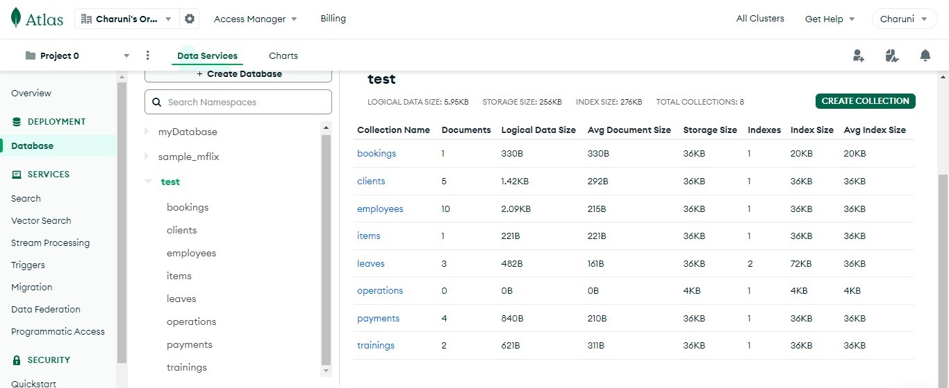

*Figure 3.3.1: MongoDB Database*

## 3.4. Algorithms

*Table 3.4.1: Algorithms*

|  |  |  |
| --- | --- | --- |
| Function | Algorithms | Description |
| User Management | Password reset Algorithm | * Request password reset * Generate OTP * Verify OTP * Reset password |
| Training Management | Training management Algorithm | * Create training course * Update training course * Delete training course * Enroll security officers in course |
| Client Management | Client inquiry management Algorithm | * Client submits inquiry * Store inquiry in the database * Notify manager * Manager responds inquiry * Update inquiry status |
| Booking Management | Booking management Algorithm | * Create booking request * Notify operation manager * Review booking * Modify booking * Cancel booking * Complete booking |
| Payment Management | Payment management Algorithm | * Generate invoice * Notify client for payment * Process payment * Update payment status * Send payment confirmation |
| Operation Management | Notification system Algorithm | * Define system event * For each event, identify recipients and prepare a notification * Send notification |
| Inventory Management | Resource allocation Algorithm | * Add new inventory item * Update inventory level * Remove inventory item * Generate inventory report |
| Leave Management | Leave management Algorithm | * Submit leave request * Update leave request * Notify manager * Track leave history |

# Section 04 - Individual Contribution

*Table 4.1: Individual Contribution*

|  |  |  |
| --- | --- | --- |
| **Student ID** | **Name with Initials** | **Tasks** |
| IT22325228 | Fernando K. K. C | * Section 1 * Section 2 * 3.2 - Completion level of the features – User Management * 3.3 – MongoDB Database * 3.4 – Algorithms * Section 4 * Section 5 |
| IT22907998 | Sadisha R. M. M | * 3.2 - Completion level of the features – Training Management |
| IT20145552 | Dissanayaka D. M. S. M | * 3.1 – Module of the group members working * 3.2 - Completion level of the features – Client Management |
| IT22257086 | Randiw E. Y | * 3.2 - Completion level of the features – Booking Management |
| IT22293480 | Jayodhya J. D. H | * 3.2 - Completion level of the features – Payment Management |
| IT22127082 | Medawatte W. W. M. T. N. B | * 3.2 - Completion level of the features – Operation Management |
| IT22132628 | Kusumsiri P. A. S. S | * 3.2 - Completion level of the features – Inventory Management |
| IT22197146 | Ranasinghe R. A. R. V. C | * 3.3 - Completion level of the features – Leave Management |

# Section 05 - Appendix

**Table 1.1:** Progress – Progress of the System

**Figure 2.1.1:** ER Diagram – System ER Diagram

**Table 2.3.1:** Test Case Design – System Test Case Design

**Figure 2.4.1:** High-level System Design – System High-level Architecture

**Table 3.1.1:** Module of the Group Members working – Group members parts of the System

**Table 3.2.1:** User Management – Completion level

**Table 3.2.2:** Training Management – Completion level

**Table 3.2.3:** Client Management – Completion level

**Table 3.2.4:** Booking Management – Completion level

**Table 3.2.5:** Payment Management – Completion level

**Table 3.2.6:** Operation Management – Completion level

**Table 3.2.7:** Inventory Management – Completion level

**Table 3.2.8:** Leave Management – Completion level

**Figure 3.3.1:** MongoDB Database – System Database

**Table 3.4.1:** Algorithms – Used Algorithms for System

**Table 4.1:** Individual Contribution – Work Distribution for this Report